**Create the records in Dynamics CRM with the blank canvas app using Patch function**

Let’s create a Canvas app with few controls to create records in Dynamics CRM. Below are the steps to create the records in Dynamics CRM.

1. Sign in to the PowerApps

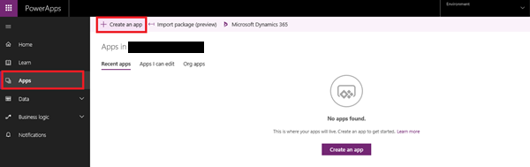

1. Click on Create an app and it will navigate to another screen. Then select Phone Layout under the blank Canvas blank.

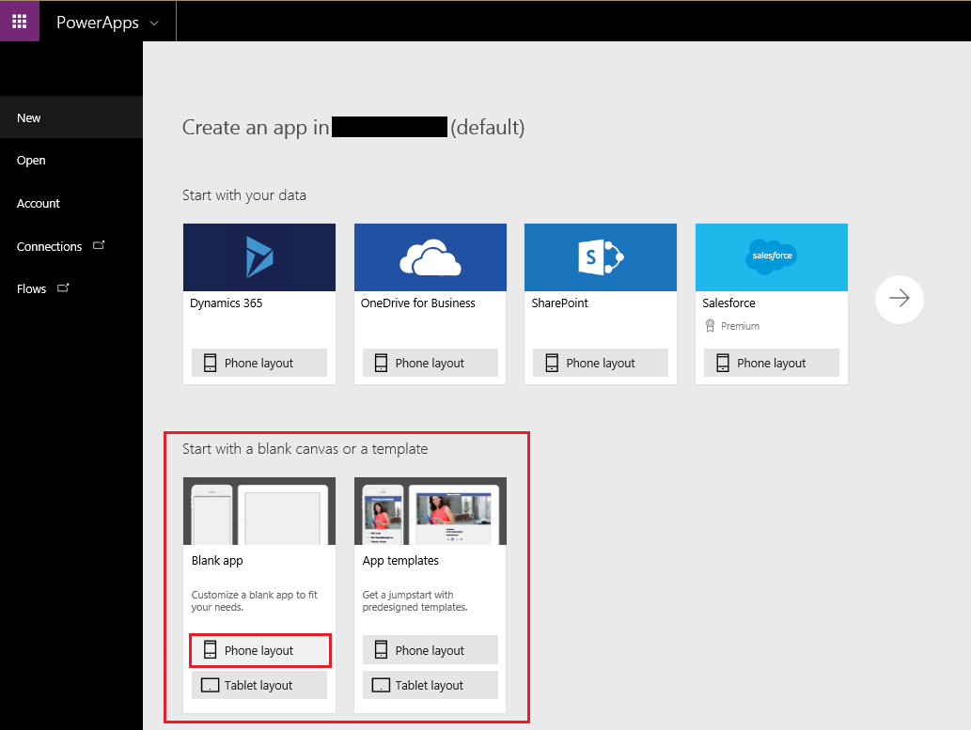

1. A blank screen will be appeared as below. You can rename it if you want,

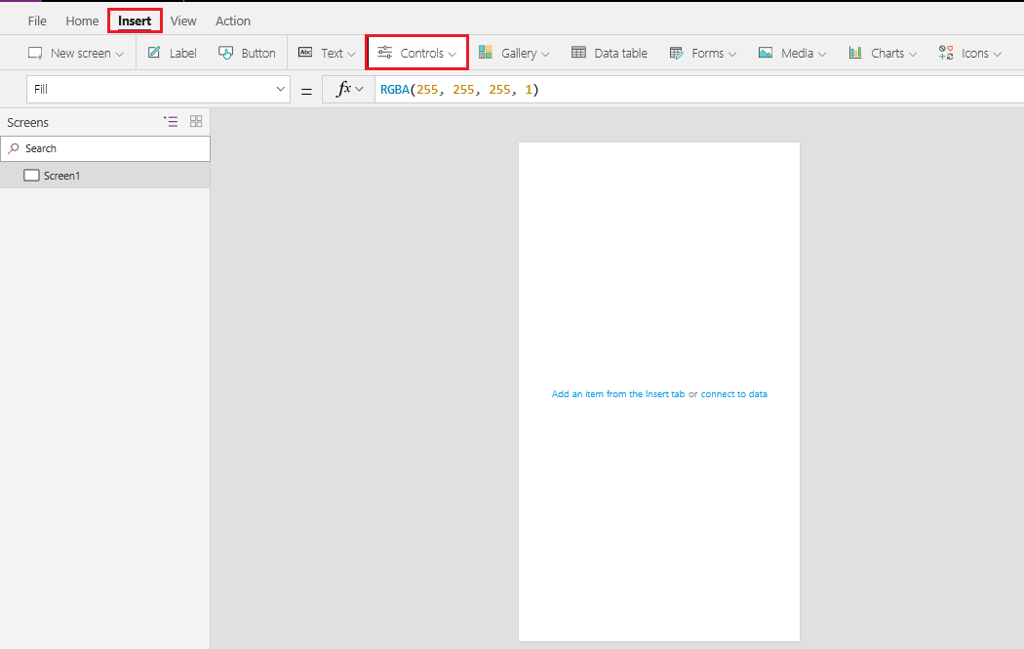

1. Add controls from the Insert Tab to the blank screen so that we can take input to save the record in CRM.
2. Here we are going to create the custom entity (**survey**) record in CRM. You can use other entity as well.

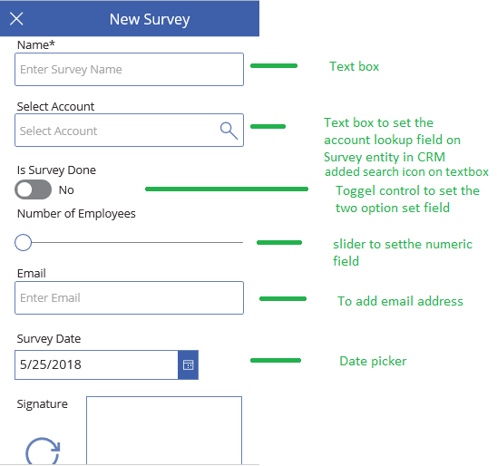

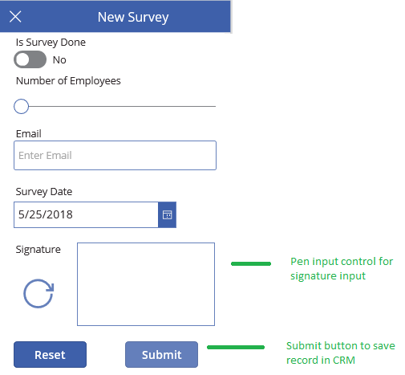

1. Set the **Min**, **Max**, **Default** property of slider control.
2. Configure the Account Lookup
   1. To set the Account lookup on Survey entity we added another screen to select the Account record
   2. To add blank screen: **Go to Insert -> New Screen -> select Blank Screen**.
   3. Add Gallery control to display the list of existing Account records in Gallery control.
   4. To add Gallery control; **Go to Insert -> select Gallery -> Select Vertical Gallery control**
3. Now set the property for Account Lookup on textbox control
   1. Set **On Select** property of search icon to

*Navigate(AccountLookup,ScreenTransition.Fade,{searchAccName : TextInputSelectAccount_3.Text }) ;Clear(SelectedAccountRecord )*

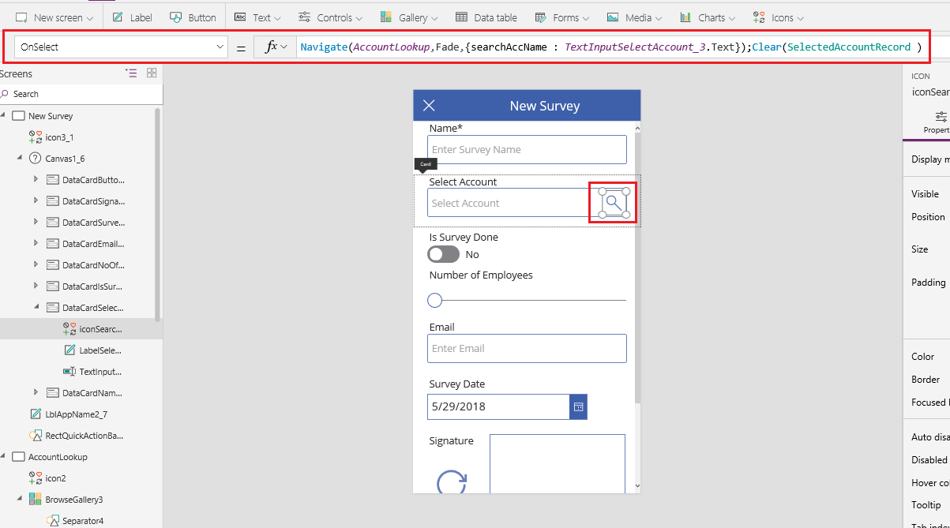

1. Here we are navigating the screen to select the Account record and also passing the value as **SearchAccName** of Select Account Textbox.
2. Set the **Default** property of Select Account textbox to

If(IsBlank(First(SelectedAccountRecord).account.accountid),Blank(),First(SelectedAccountRecord ).account.name)

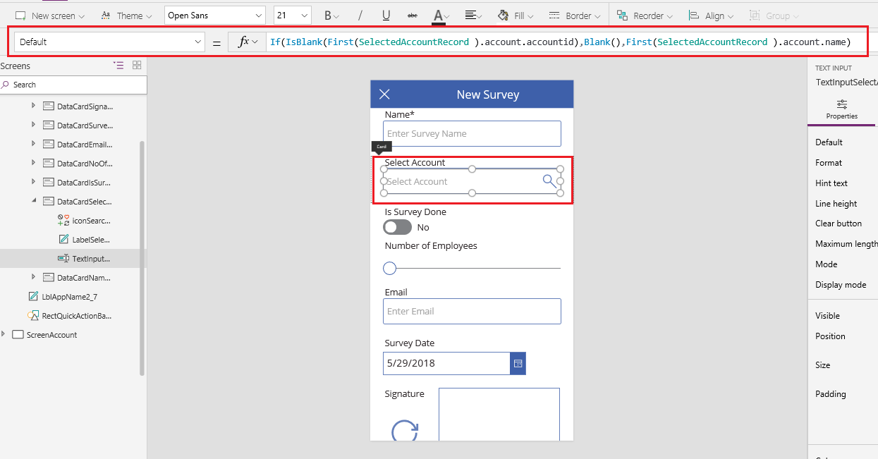

1. Here we are displaying the selected account name from the Account Gallery in the textbox. Initially it will display blank.
2. To select CRM Account Record, we added another blank screen.
   1. **Insert – > New Screen**

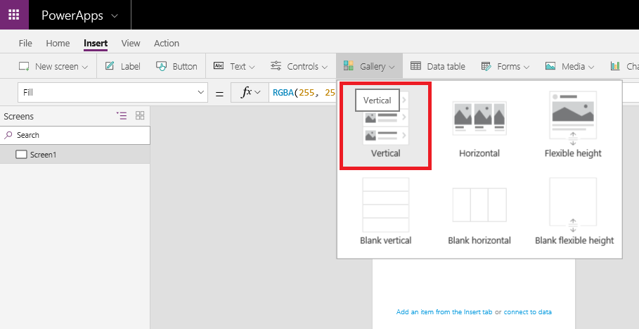

1. Now add Account data source: **Select view -> Data Source – > Select the connection and then add the Account Data Source**

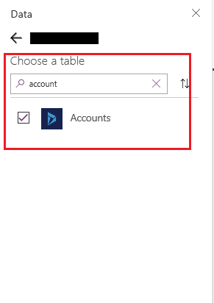

* 1. Now set the Gallery **Item** Property to *If(IsBlank(searchAccName), Accounts,Search(Accounts,searchAccName,”name”))*

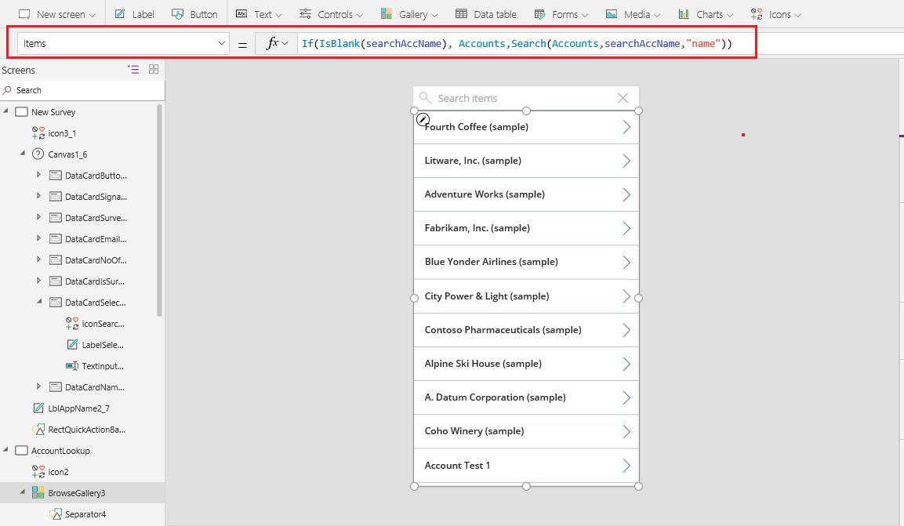

1. Here the Gallery will display the list of the accounts with matching name in **searchAccName** variable from previous screen. If **searchAccName** is empty then it will show all accounts.
   1. Set **On select** property of Arrow on BrowsGallery to *ClearCollect(SelectedAccountRecord , {account : BrowseGallery3.Selected});Reset(TextSearchBox3); Back()*

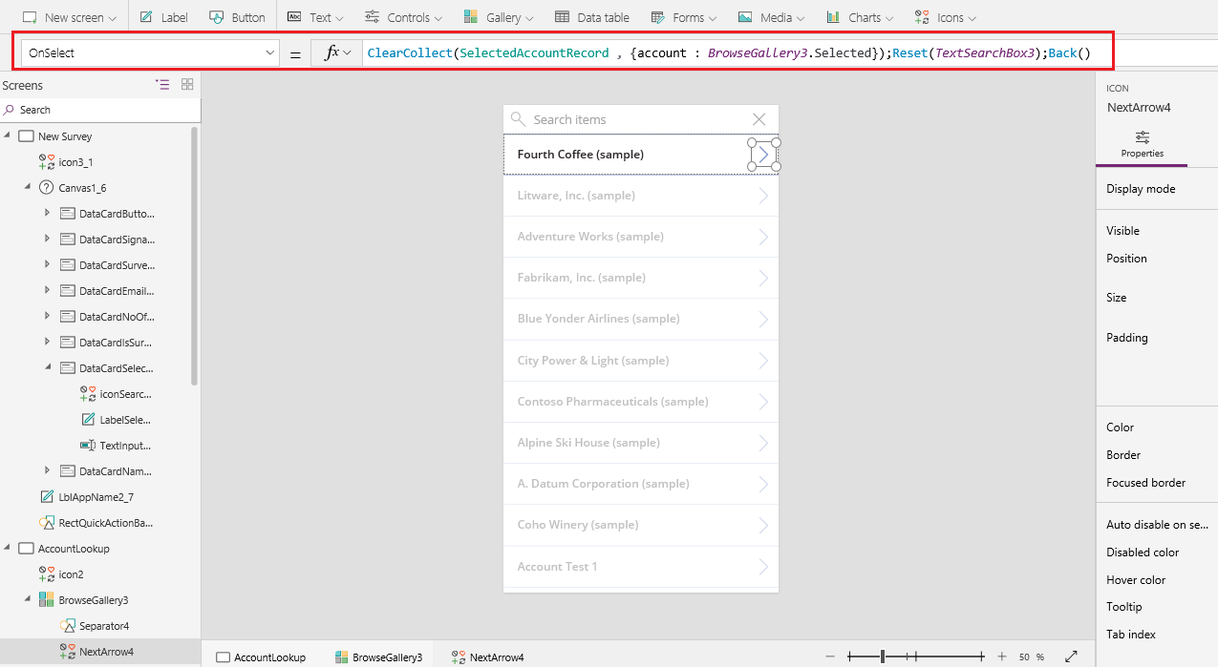

1. Here we are storing the selected account record in the separate collection i.e. **SelectedAccountRecord**.
2. Set the **On select** property of **Submit**button - Here we need to add the Data source for the Custom entity (**Survey**)
   1. Set the **On select** property of **Submit**button to *Patch(‘Survey”s’,Defaults(‘Survey”s’),{new_name:TextInput2Name_2.Text,new_issurveydone : ToggleIsSurveyDone_4.Value , new_noofemployee :Value(Slider1_1.Value),new_email :TextInputEmail_3.Text,new_surveydate : DatePicker1_3.SelectedDate ,new_signature : Signature_1.Image,_new_selectaccount_value:If(IsBlank(First(SelectedAccountRecord).account),Blank(),First(SelectedAccountRecord).account.accountid)});*
3. In Patch function we will set the values of controls to the Survey data source columns.

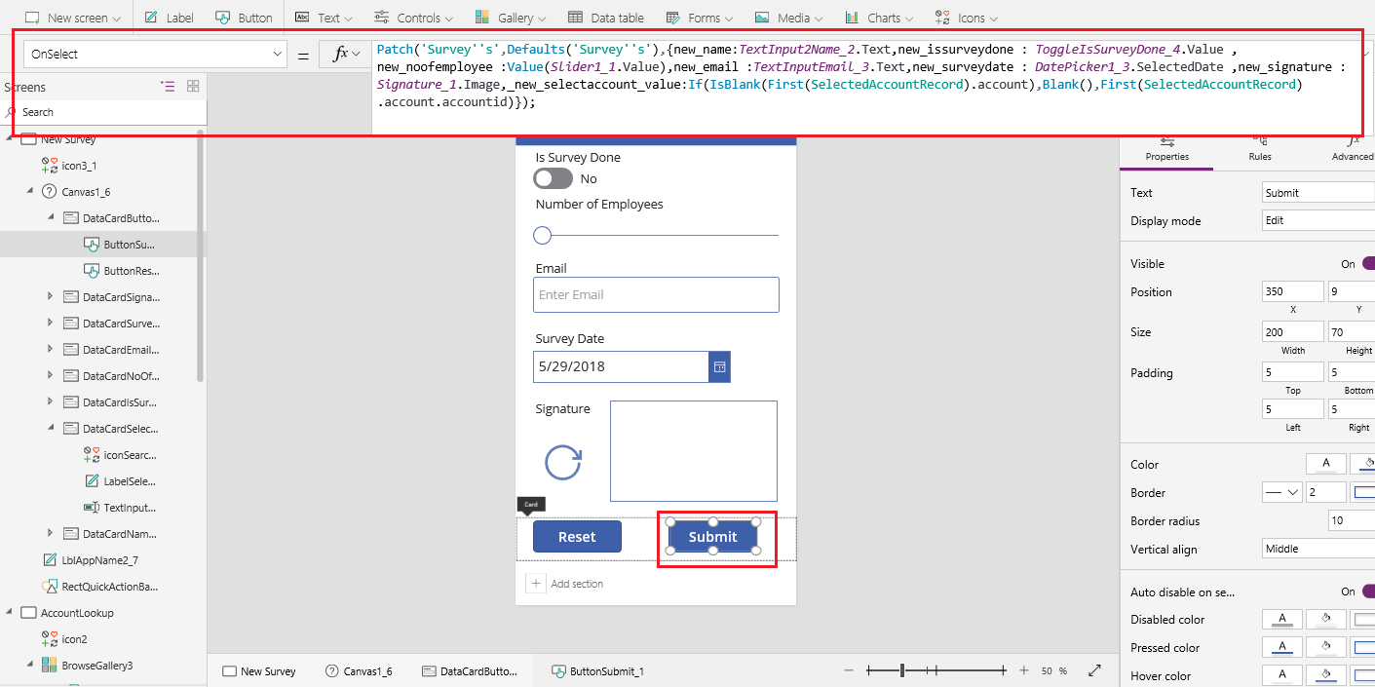

1. Now save and publish the app to reflect the changes on mobile device. Now play the App from PowerApp Studio as you can see in the below screenshot:

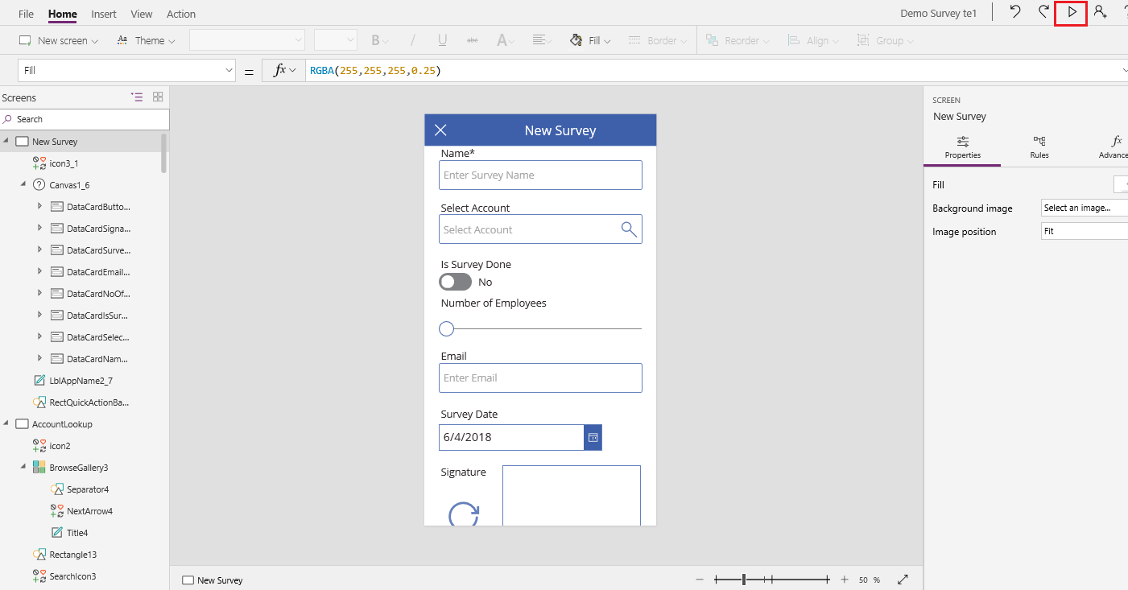

Output

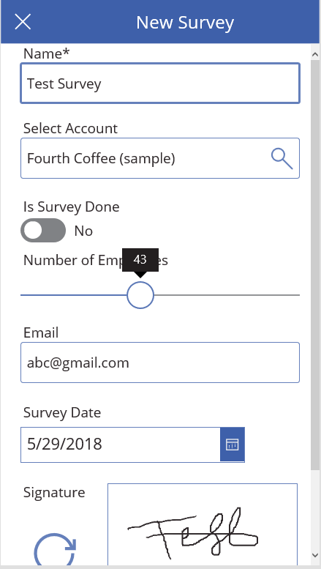

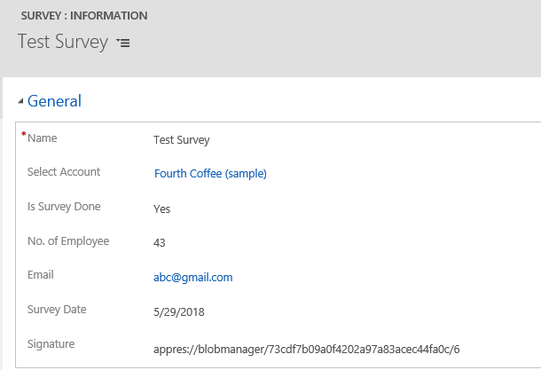

**Note**: The pen input control will give BLOB data string and this signature will not be displayed on the Dynamics 365 for Phone app.